Audio Resources Available to Students with Dyslexia or Other Reading Difficulties

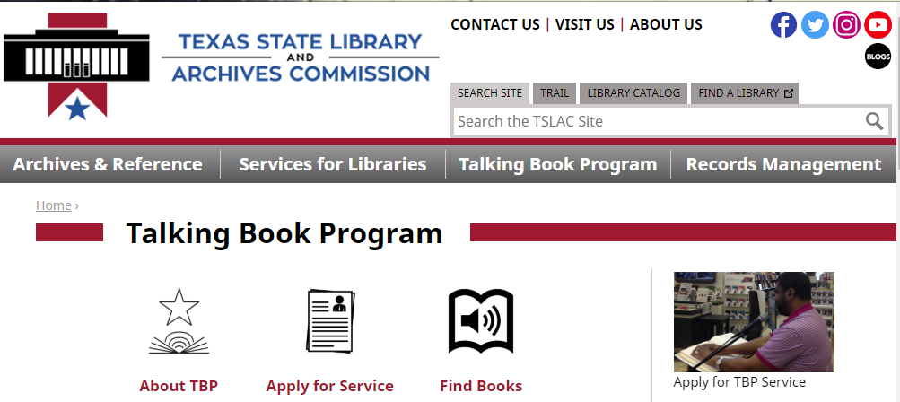
In accordance with TEC §28.006 (g-2), _________ ISD is notifying you of the Talking Book Program (TBP), an audiobook resource that may be available to your child.
Access the student application at this site: https://www.tsl.texas.gov/sites/default/files/public/tslac/tbp/application/ Reading%20Disabilities%20Application%202019.pdf

Contact 1-800-252-9605 for additional assistance.
TEC §28.006 (g-2) requires school districts to notify the parents or guardians of students determined, on the basis of dyslexia screening or reading instrument results to have dyslexia or a related disorder, or to be at risk for dyslexia or other reading difficulties, to have access to the Talking Book Program (TBP) maintained by the Texas State Library and Archives Commission. The TBP provides students with reading disabilities the ability to borrow audiobooks free of charge, and it includes over 100,000 titles, hundreds of which are in Spanish.

Additional audiobook resources to consider are available from Bookshare and Learning Ally. For more information, you can access the websites listed below, call the customer service numbers, or contact your student’s campus dyslexia instructor, §504, or IDEA coordinator.
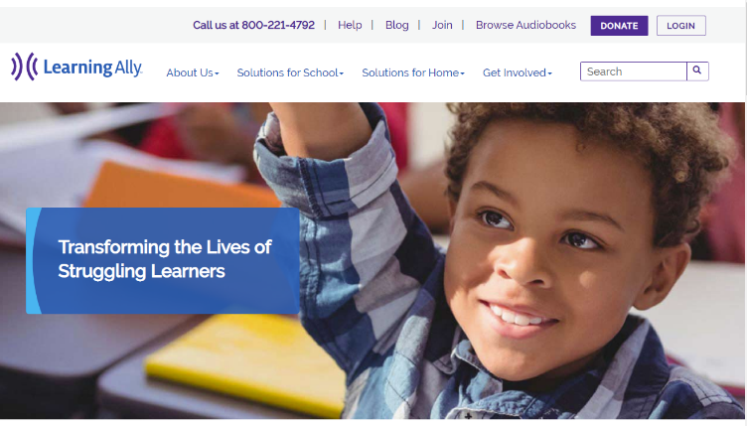
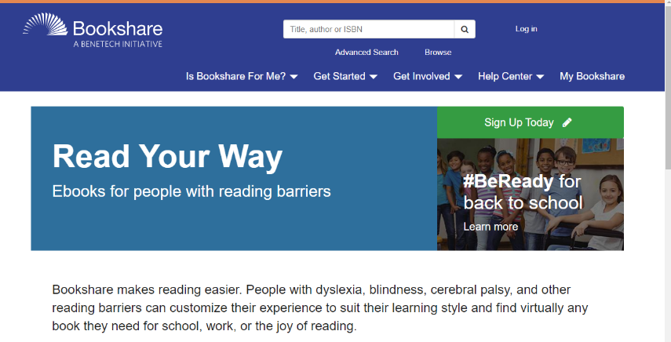
You may access The Texas Dyslexia Handbook: Dyslexia and Related Disorders 2018 https://tea.texas.gov/academics/special-student-populations/review-and-support/dyslexia-handbook

www.learningally.org
or 1-800-221-4792
Jennifer Huff, jhuff@learningally.org

www.bookshare.org/cms/
or 1-650-644-3449

